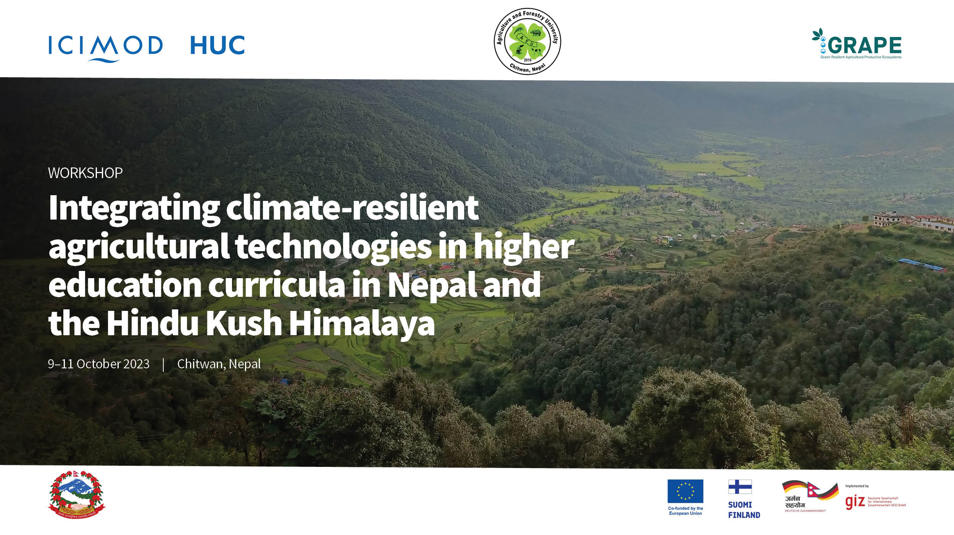

The three-day consultative workshop on "**Integrating Climate-Resilient Agricultural Technologies into Higher Education Curricula in Nepal and the Hindu Kush Himalaya**" has concluded with resounding success. The workshop was a collaborative effort between ICIMOD and Agriculture & Forestry University, with support from The Green Resilient Agricultural Productive Ecosystem (GRAPE) project, and the Himalayan University Consortium (HUC), and took place in Bharatpur, Chitwan, Nepal from Oct. 9-11, 2023.

During this international event, esteemed university teaching faculty members as well as delegates from national universities (Tribhuvan University, Purbanchal University and Kathmandu University), international delegates from Universities of India, Bhutan, Vietnam, Bangladesh as well national experts from NARC, MoALD and international experts engaged in profound discussions, emphasizing the paramount importance of incorporating climate-resilient agriculture into higher education curricula.

The workshop's primary objectives were to sensitize university stakeholders to the significance of climate-resilient agriculture, underscore the pivotal role of academic curricula in enhancing overall climate resilience, and elucidate the process of integrating climate-resilient strategies into academic programs. The active engagement and generous support by the workshop delegates have been instrumental in making this workshop a resounding success. Throughout the time together, all the participants engaged in profound discussions, highlighting the paramount importance of incorporating climate-resilient agriculture into higher education curricula. The experience was truly enlightening and transformative, with each one of having profound and valuable contributions.

One of the workshop's notable achievements was the comprehensive evaluation of the B.Sc. Ag. curriculum, which provided invaluable insights and feedback crucial for its subsequent revision. This workshop has undeniably contributed to advancing the cause of climate-resilient agriculture in Nepal and the broader Himalayan region, reflecting with sustainable approach to incorporate in Agriculture Higher education.

|  |
| --- |
|  |
|  |
|  |